Development Tutorial
Tab Menu Tutorial
prepared by Goran Zidar

Abstract
This document exists to instruct readers in the use of the tabbed menu interface controls to allow VFP applications to make use of a Microsoft Office 2007 style menu system.

Revision Information
Version | Details | By | Date
0.1 | Initial Draft | Goran Zidar | 13/02/2007
0.2 | Added example of working with menu designer | Goran Zidar | 17/02/2007
0.3 | Added generator extension notes | Goran Zidar | 24/02/2007
0.4 | Incorporated feedback from reviewers | Goran Zidar | 01/03/3007
1.0 | Initial Release | Goran Zidar | 02/03/2007

Contents
Abstract 2
Revision Information 2
Contents 2
Acknowledgements 2
Where is the File Menu? 3
The Office Components 3
The FoxPro Components 4
Worked Example 5
The Quick Bar 7
The Menu Items 7
The Popups 7
The Popup Items 8
The Start Item 8
The Hotkeys 9
Processing the user actions 10
The Results 10
The FoxPro Menu Designer 11
Menu Generator Extensions 13
The Next Steps 14

Acknowledgements
No software project like exists in a vacuum and this is no exception. The utility being discussed in this document would be a shadow of its current self without the valuable feedback and assistance of a number of people, most notable is Darren de Roia – who’s ideas and suggestions have certainly made this utility into something that I believe is truly usable in a wide range of applications. Oscar Zarate gave me useful feedback in reviewing this document and his encouragement was welcomed. Craig Bailey who published the very sketchy first preview of this on his blog and motivated me to keep persisting because he believed that this was a worthwhile endeavour. In addition to these individuals I do want to acknowledge the entire VFP community, because without you guys being there then I very much doubt this tool would have been possible. The amount of information I was able to obtain regarding methods an techniques was amazing and I am glad that I am able to give something back to that community.
Where is the File Menu?
The first time I opened Microsoft Office 2007 I experienced the WOW factor that Microsoft was promoting for the release of Vista. Shortly after that I thought, I wonder if we can do this in Visual FoxPro? Well guess what, it seems you can. This document will describe the way Microsoft Office’s radical and innovative new menu interface can be used within a Visual FoxPro application, the only requirement is that you run under VFP 9 as this code makes use of Windows Message Event binding and this feature did not exist in prior versions of the language – other than that the code uses standard VFP, there are no ActiveX controls, no DLLs, no FLLs, nothing except core VFP and some basic API calls.

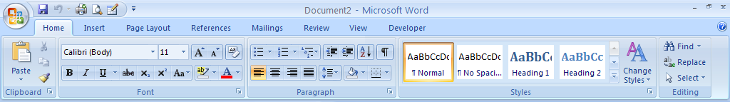
Figure 1: Microsoft Office 2007 Word Menu

As you can see the new Office menu system is a significant departure from what we have been used to seeing for many years. Gone is the menu bar, gone are the toolbars, gone is the File menu. Instead what we are left with is a slick looking hybrid of the two with a big circular button just asking to be pushed; even the sanctity of the title bar has been conscripted into active service.

It takes a bit of getting used to but once the initial confusion becomes curiosity I found that the new interface was a really good way to present choices to a user. After all, a toolbar was just a shortcut to a menu option so why not combine the two concepts into one – far more visually appealing – interface.

The Office Components
The first thing we need to do is to break the menu interface down into its component parts. Please be aware that I am making these names up but I needed to call them something so I could make the classes I needed so don’t take offence if I have misnamed a widget – the error (if any) is entirely mine.

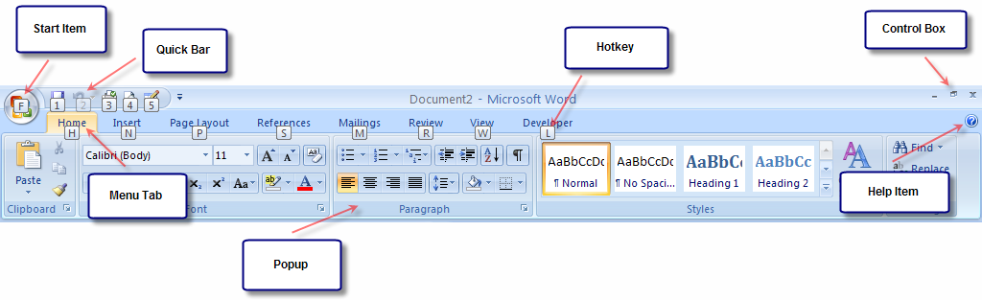
Figure 2: Office Word Menu Components

The image above shows the various components and the list below describes their purpose in the VFP interface equivalent.

Component Name | Description
Start Item | This component holds the items that used to be found on the File Menu as well as any additional menu options that the user may need to interact with your application.
Quick Bar | This component is very similar to the toolbars we are all used to. It provides a shortcut to commonly used actions.
Menu Tab | This is a collection of controls that group regular user functions.
Popup | This component is a sub-grouping of options within a menu tab.
Hotkey | This little icon becomes visible when the user presses the ALT key to display the keyboard shortcuts to the menu options.
Help Item | The application help menu icon.
Control Box | The Minimize, Maximize and Close box for the interface. Since the new menu system has replaced the standard form title bar this box allows the user to still access the functions to shutdown or minimize the application.

In addition to the above there is one more component. The screen below is displayed when the user presses the Start Item.

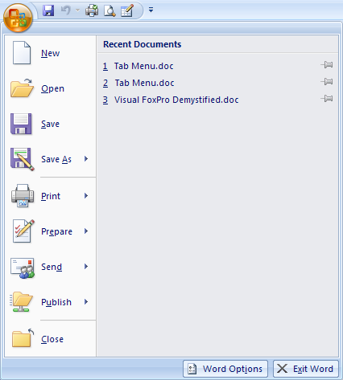
Figure 3: Start Item Popup Screen

As you can see the save and print options on this popup have been reproduced in the quick bar but the things to notice are the Exit button and the pushpin on the Recent Documents list.

The FoxPro Components
The underlying principle behind a menu is that the menu selections should not in any way interfere with the work the user is doing on the active screen. For this basic reason the entire tabbed menu interface has been contained within a VFP toolbar because according to the VFP help many controls placed in a toolbar do not receive focus when they are chosen. Beyond that all the other components are based on the container control and the form (for the Start Item popup).

Because the tabbed menu interface is intended to be used without requiring code changes directly within the components the developer must interact with the components by making use of the BINDEVENTS() function. In addition BINDEVENTS() is used to ensure that menu-like behaviour is exhibited when the user presses the hotkeys. Thus in order to use the menus code must be placed in each of the application’s forms to provide that interaction but given VFP’s object orientation this should not be too much of an imposition for a developer to accept.

The components to implement the menu is contained within the tabmenu.vcx class library and the design goal has been that there is no requirement for a developer who wishes to make use of the menu to change that code. The table below lists the classes and provides a brief description of each one.

Class | Description
cntControl | The minimize, maximize and close buttons on the top right hand side of the window.
cntHelpItem | The small question mark button on the right hand side of the menu strip.
cntMenuItem | The tabs that make up the menu.
cntPopupItem | The actual menu options.
cntPopupMenu | A container for the popup items displayed when a particular menu tab is selected.
cntQuickBar | The collection of options displayed on the left of the title bar.
cntQuickItem | The buttons contained within the quick bar.
cntSearchBox | A text box displayed on the menu strip next to the help item to provide a text search within the application.
cntStartItem | The main menu item displayed on the top left hand side of the menu strip.
cntTabMenu | The controlling container which puts all the various components together.
frmStartMenu | The base start menu popup screen.
tbrTabMenu | The toolbar which holds an instance of the cntTabMenu container.
frmPopup | The base menu popup form, used to provide the submenu functionality

Worked Example
I find that the best way to explain how something works is to go through a practical example. The examples within this document are obviously extremely trivial and certainly do not attempt to represent real world application development so shortcuts have been taken to expedite the solution.

In the main program of a VFP project make sure that the tabmenu class library is available and that the path to the image files is set. Because the menu is contained within a toolbar control the application must have a top level form – be that the VFP Screen or some other VFP form. In this example we will create a VFP form with the following properties and create the form object in the project’s main program.

Property | Value
BorderStyle | 0 – no border
ShowWindow | 2 – As top level form
TitleBar | 0 – Off
oToolbar | .null.

The following methods should be created or overridden as shown:

Method | Code
Activate | Application.Visible = .f.  IF VARTYPE(thisform.oToolbar) = "O"  thisform.oToolbar.Refresh()  ENDIF
Destroy | UNBINDEVENTS(this.HWnd)  Application.Visible = .t.  CLEAR EVENTS
Init | thisform.Width = SYSMETRIC(1) + 30  thisform.Left = -15  thisform.Top = 0 - (SYSMETRIC(9) + 5)  DECLARE INTEGER GetWindowLong IN Win32API INTEGER hWnd, INTEGER nIndex  #define GWL_WNDPROC (-4)  this.nOldProc = GetWindowLong(this.Hwnd, GWL_WNDPROC)
TabMenuHandler | (empty for now)
AppMinimize | thisform.WindowState = 1
AppExit | CLEAR EVENTS  thisform.Release()

The TabMenuHandler() method will be used to include the code which executes when the menu options are selected. In this example program all the menu options will be handled by this method but obviously this can be done differently for each implementation. You could have a custom event handler for each and every menu option if you like, it is all driven by the event binding functionality in VFP (more on that later).

In the main program the Top Level form is created and assigned to a public variable, if you are using the VFP Screen you need not worry because that _SCREEN variable is already public. The reason for the public variable is because you need to be able to get to the toolbar from each of your forms and for the purposes of this example a public variable is the easiest. Once the form is created and made visible the toolbar is created and attached to a property in the form.

The code in the Init() of the form exists to hide the normal window title bar and borders because the tab menu can optionally add its own title bar. It also stores the Windows Process number for the form which we need for some of the event binding because in order for the toolbar’s control box to function as expected we need to bind to windows events as shown here:

#define WM_ACTIVATEAPP 0x001C

BINDEVENT(goForm.Hwnd, WM_ACTIVATEAPP, goForm.oToolbar.cnttabmenu, "WMEventHandler")

From here a few properties need to be set on the toolbar and then you can begin to add the menu components. The toolbar should be docked at the top of the form, I am going to set the caption of the toolbar’s faux title bar and I am going to make the form’s height equal to that of the toolbar since in this example the user interface forms will appear in the Windows desktop.

goForm.oToolbar.cnttabmenu.nOldProc = goForm.nOldProc
goForm.oToolbar.cnttabmenu.cCaption = "Visual FoxPro User Interface Test"
goForm.oToolbar.Dock(0,0,0)
goForm.oToolbar.cnttabmenu.Width = goForm.Width - 30
goForm.Height = goForm.oToolbar.Height

Also we want the main form to process the minimize and close events raised when the user clicks the control box and this is done via the BINDEVENT() function as show here.

BINDEVENT(goForm.oToolbar.cnttabmenu, "AppMinimize", goForm, "AppMinimize")
BINDEVENT(goForm.oToolbar.cnttabmenu, "AppExit", goForm, "AppExit")

I am going to assume we want to the tab menu to include each of its optional components, so with this in mind let’s continue by discussing each component and how you add your own items to the menu.

The Quick Bar
The quick bar appears in the top left hand corner of the title bar. It can only be made visible if the toolbar is showing the title bar. The quick bar items are limited to 21x21 pixels in size and do not show any text; though a tooltip is available, the hotkeys are automatically assigned as numbers 1 to n depending on the order that the items are added. This is done by calling a method on the toolbar and then setting a few properties on the returned object. Rather than go on talking, here is the code:

goForm.oToolbar.cnttabmenu.lShowQuickBar = .t.

loItem = goForm.oToolbar.cnttabmenu.cntQuickBar.AddItem("new.bmp")
loItem.cItemKey = "QUICK.OPTION1"
loItem.ToolTipText = "Tool tip for option 1"
BINDEVENT(loItem, "Execute", goForm, "TabMenuHandler")

loItem = goForm.oToolbar.cnttabmenu.cntQuickBar.AddItem("edit.bmp")
loItem.cItemKey = "QUICK.OPTION2"
loItem.ToolTipText = "Tool tip for option 2"
BINDEVENT(loItem, "Execute", goForm, "TabMenuHandler")

The first line tells the toolbar that the quick bar is visible, the next two blocks of code add two items to the quick bar and sets their item key and defines the tool tip to display. The Quick bar items have an event called Execute that is raised when the option is selected by the user and the BINDEVENT() calls allow us to add our own code to those events.

The Menu Items
The menu items are added next these appear below the title bar and will automatically resize to fit their caption. The hotkeys for the menu tabs are defined by the developer as are any conditions that are used to determine if the menu tab is active or inactive (this last aspect is true for all components of the tab menus). The code required to add the menu tabs is shown here:

loMenu = goForm.oToolbar.cnttabmenu.Addmenuitem("Home","H")
loMenu = goForm.oToolbar.cnttabmenu.Addmenuitem("Programs","P")
loMenu = goForm.oToolbar.cnttabmenu.Addmenuitem("Reports","R")

The code above will add three menu tabs to the toolbar with the captions, Home, Programs and Reports and hotkeys, H,P and R respectively. There is no requirement to bind to an event here as the purpose of the menu tabs is to display the popups which appear below them.

The Popups
The popups are used to group the actual tab menu options, this is the guts of what we are trying to achieve a way for the users of your system to interact with the menu system. I know that technically these menu options don’t pop up but the term stems from what they were trying to replace – the actual menus.

A popup is added first and then the popup items are added to the popup. A popup has a caption describing the controls contained within it and it is attached to a particular menu tab, the developer can also specify the number of columns they want their popup to consist of and the width of the popup (among other things). The code to add a popup is shown here:

loPopup = goForm.oToolbar.cnttabmenu.AddPopup("Home #1", 1)
loPopup.nColumns = 3
loPopup.Width = (loPopup.nColumns * 100)

In the above example a popup called Home #1 is added to the first menu tab. It is defined with 3 columns and each column is 100 pixels wide. The decision regarding the number of columns and the width of each column is arbitrary as the tab menu will automatically adjust the size of the popup items to fit within the popup they belong to.

The Popup Items
Once the popup is created the popup items need to be added. This is done by calling the AddPopupItem() method on the popup object returned by the AddPopup() call above. The call to add the popup accepts 3 parameters, the first being the Caption, the second the size of the popup and the hotkey. Once the popup item is created the developer is able to set other properties to define the way the popup item will appear. As with the quick bar items above BINDEVENT() is used to like the developer code to the act of the user selecting a popup item.

loItem = loPopup.AddPopupItem("Option 1", "NORM", "A")
loItem.cPicture = "New.bmp"
loItem.ToolTipText = "This is an example tool tip"
loItem.cItemKey = "HOME.OPTION1"
BINDEVENT(loItem, "Execute", goForm, "TabMenuHandler")

loItem = loPopup.AddPopupItem("Option 2", "NORM", "B")
loItem.cPicture = "Edit.bmp"
loItem.cItemKey = "HOME.OPTION2"
BINDEVENT(loItem, "Execute", goForm, "TabMenuHandler")

loItem = loPopup.AddPopupItem("Option 3", "NORM", "C")
loItem.cSkipForExp = "VARTYPE(_SCREEN.activeform)='O' AND _SCREEN.Activeform.ShowWindow<>2"
loItem.cItemKey = "HOME.OPTION3"
BINDEVENT(loItem, "Execute", goForm, "TabMenuHandler")

loItem = loPopup.AddPopupItem("Option 4", "NORM", "D")
loItem.cItemKey = "HOME.OPTION4"
BINDEVENT(loItem, "Execute", goForm, "TabMenuHandler")

loItem = loPopup.AddPopupItem("Option 5", "NORM", "E")
loItem.cItemKey = "HOME.OPTION5"
BINDEVENT(loItem, "Execute", goForm, "TabMenuHandler")

loItem = loPopup.AddPopupItem("Option 6", "NORM", "J")
loItem.cItemKey = "HOME.OPTION6"
BINDEVENT(loItem, "Execute", goForm, "TabMenuHandler")

The code above will add six popup items to the popup created before this and will set the hotkey, picture, tool tip and active condition where relevant. The cItemKey property is optional but it provides for a way to determine what menu object was selected by the user when processing the events. In this example we will use this key to decide what action to take because I am binding all the menu options to the same event handler.

The Start Item
The final part of the menu is the start item. This control does not have much in the way of default behaviour it requires you to create a subclass of the frmstartmenu class. The base class does not actually contain any functionality it simply provides the framework needed to interact with the tab menu system. Therefore you will need to add your own code to this subclass to make the start menu popup do anything. The first thing that you need to do is tell the tab menu what class it should instantiate when the start item is pressed. The code below shows how this can be done.

goForm.oToolbar.cnttabmenu.cfrmStartClass = "frmExampleStart"

Now that the tab menu knows what class to create we need to add code to that class to make it do something. In this example I am just going to add popup items to the containers that exist in the base class exactly like we have done already in the code examples above.

This code is added to the Init() of the form and is shown here:

LPARAMETERS voTabMenu, vlShowHotKeys

IF DODEFAULT(voTabMenu, vlShowHotKeys)
LOCAL loItem

loItem = thisform.cntMenuItems.cntRecentItems.Addpopupitem("Recent Item 1", "NORM", "1")
loItem.lShowPin = .t.
loItem = thisform.cntMenuItems.cntRecentItems.Addpopupitem("Recent Item 2", "NORM", "2")
loItem.lShowPin = .t.
loItem = thisform.cntMenuItems.cntRecentItems.Addpopupitem("Recent Item 3", "NORM", "3")
loItem.lShowPin = .t.
loItem = thisform.cntMenuItems.cntRecentItems.Addpopupitem("Recent Item 4", "NORM", "4")
loItem.lShowPin = .t.
loItem = thisform.cntMenuItems.cntRecentItems.Addpopupitem("Recent Item 5", "NORM", "5")
loItem.lShowPin = .t.

thisform.cntMenuItems.cntQuickMenu.Addpopupitem("Quick Menu 1", "LARGE", "A")
thisform.cntMenuItems.cntQuickMenu.Addpopupitem("Quick Menu 2", "LARGE", "B")
thisform.cntMenuItems.cntQuickMenu.Addpopupitem("Quick Menu 3", "LARGE", "C")
thisform.cntMenuItems.cntQuickMenu.Addpopupitem("Quick Menu 4", "LARGE", "D")
ELSE
RETURN .f.
ENDIF

This code will add five items to the right hand side container and four items to the left hand side container. The right hand items include a visible pin and the left hand items are large popup items. This form will now be displayed when the user selects the start item from the menu.

The containers on the form are instances of the popups used in the menu and therefore offer all of the same functionality. Thus in order to attach your own code to be executed when the user selects an item from this screen you need to use BINDEVENT() as we have shown previously.

The Hotkeys
Now that we have defined all the menus, popups and quick bar items we need to allow the user to access these via their keyboard as well as using the mouse. Thus we need to bind to a few more Windows events to ensure that the menu behaves as expected.

The code to achieve this is shown below and must be placed in the main program and the Init() of the forms used within your application.

#define WM_KEYDOWN 0x0100
#define WM_KEYUP 0x0101
#define WM_SYSKEYUP 0x0105

BINDEVENT(goForm.Hwnd, WM_KEYDOWN, goForm.oToolbar.cnttabmenu, "WMEventHandler")
BINDEVENT(goForm.Hwnd, WM_KEYUP, goForm.oToolbar.cnttabmenu, "WMEventHandler")
BINDEVENT(goForm.Hwnd, WM_SYSKEYUP, goForm.oToolbar.cnttabmenu, "WMEventHandler")

Processing the user actions
We have now finished defining the contents of the tab menu and all we need to do is make it actually do something. As you can see we have bound all the menu events to the TabMenuHandler() method of the main form which thus far we have left blank. This method is where the code to process the user actions must be placed. For the purposes of this example place the following code within that method:

PRIVATE paSource

AEVENTS(paSource, 0)

DO CASE
CASE VARTYPE(paSource[1].cItemKey) = "C" AND paSource[1].cItemKey = "HOME.OPTION1"
DO FORM testform
CASE VARTYPE(paSource[1].cItemKey) = "C" AND paSource[1].cItemKey = "HOME.OPTION2"
DO FORM testform2
CASE VARTYPE(paSource[1].cItemKey) = "C" AND paSource[1].cItemKey = "HOME.OPTION3"
IF VARTYPE(_screen.ActiveForm) = "O"
_screen.ActiveForm.Release()
ENDIF
OTHERWISE
MESSAGEBOX(paSource[1].name + " active form:" + ;
_screen.activeform.name + " " + ;
paSource[1].cItemKey, 4096, "Test")
ENDCASE

The code above will process the actions of the bound controls, as you can see the code assumes that you have two forms created, testform and testform2 which will be launched when the user selects Option 1 and Option 2 from the Home menu tab.

These forms can have anything you want contained on them the only requirement is that the following code be added to them as shown in the table below:

Method | Code
Init | #define WM_KEYDOWN 0x0100  #define WM_KEYUP 0x0101  #define WM_SYSKEYUP 0x0105  BINDEVENT(this.Hwnd, WM_KEYDOWN, goForm.oToolbar.cntTabmenu, "WMEventHandler")  BINDEVENT(this.Hwnd, WM_KEYUP, goForm.oToolbar.cntTabmenu, "WMEventHandler")  BINDEVENT(this.Hwnd, WM_SYSKEYUP, goForm.oToolbar.cntTabmenu, "WMEventHandler")
Activate | goForm.oToolbar.Refresh()

The Results
Once all the coding has been done as described above the following is produced (see below). As you can see it’s not exactly the same as the Office 2007 menus but it’s pretty close.

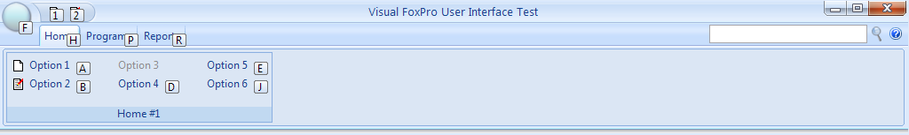
Figure 4: The Visual FoxPro Tab Menu

When the start item is pressed the following is shown:
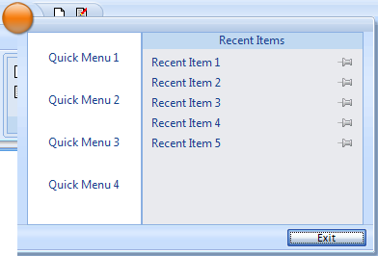
Figure 5: Start Item Popup Screen

The FoxPro Menu Designer
The example above requires the developer to hand code the menu and this is something that VFP developers have not ever had to do. Well the same is true for the tab menus, you can continue to make use of the VFP menu designer because the tab menu components also include a tab menu generator program to convert your existing VFP menu into the tabbed menus we have been talking about.

In many cases you will not need to make any changes at all to your menus to take advantage of the new interface but if you want to get the best results you may need to slightly alter the menus you have built. But before I begin describing these its time for a few caveats.

- The tabmenugenerator.prg file does not understand GenMenuX extensions so if you have made extensive use of these you might have some additional work to do.
- The generator does nothing at all for the start item popup so you will need to code this separately.

Now that we have those constraints out of the way let’s start explaining how the menu designer can be used. To do this I will begin by describing the way to create the exact same menu as the one shown in the manual example above.

The main program – like before – must have a path to the image files and make the tabmenu.vcx class library available, the difference however is a call to the menu file; in this example it will be called sample.mpr. We will be reusing the form created from the previous example so the code required in the main program is rather simple, in fact the entire main program is shown here:

SET PATH TO u:\devsource\tabmenu\images\
SET CLASSLIB TO "tabmenu.vcx", "example.vcx"

RELEASE goForm
PUBLIC goForm AS Form

goForm = CREATEOBJECT("cfrmMain")
goForm.Caption = "Visual FoxPro User Interface Test"
goForm.Show()

DO sample.mpr

READ EVENTS

RELEASE goForm

From here the remaining work will be done using the Visual FoxPro menu designer, of course in order for the tab menu code to be generated the _GENMENU path must be set to the gentabmenu.prg file.

Create a new menu just as you would normally open the menu designer and add three submenus to the main menu; Home, Programs and Reports. Then click on the options of each of these and set the properties as shown in the table below:

Menu Pad | Property | Value
Home | Shortcut Key Label | CTRL+H
 | Shortcut Key Text | H
Programs | Shortcut Key Label | CTRL+P
 | Shortcut Key Text | P
Reports | Shortcut Key Label | CTRL+R
 | Shortcut Key Text | R

This defines the menu tabs and sets the Hotkeys for selecting those tabs. The CTRL part of the hotkey is ignored by the generator but because the menu designer does not support plain characters the CTRL key must be used.

Now we need to define the popup for the home menu. In the example above we had six options contained in a popup with a caption of Home #1, we will duplicate this using the menu designer. Edit the Home submenu and add another submenu called Home #1, this becomes the popup caption and allows us to add code to modify the appearance of that popup. Then you edit that submenu and add the actual options and the code to customise the popup. The information you need to add to each of the menu options is shown here:

Menu Item | Property | Value
Option 1 | Shortcut Key Label | CTRL+A
 | Shortcut Key Text | A
 | Picture File | New.bmp
 | Message | This is an example tool tip
 | Command | DO FORM testform
Option 2 | Shortcut Key Label | CTRL+B
 | Shortcut Key Text | B
 | Picture File | Edit.bmp
 | Command | DO FORM testform2
Option 3 | Shortcut Key Label | CTRL+C
 | Shortcut Key Text | C
 | Skip For | NOT (TYPE('_SCREEN.activeform')='O' AND _SCREEN.Activeform.ShowWindow<>2)
 | Procedure | IF TYPE("_screen.ActiveForm") = "O"  _screen.ActiveForm.release()  ENDIF
Option 4 | Shortcut Key Label | CTRL+D
 | Shortcut Key Text | D
Option 5 | Shortcut Key Label | CTRL+E
 | Shortcut Key Text | E
Option 6 | Shortcut Key Label | CTRL+Q
 | Shortcut Key Text | Q

The following code is placed in the Home1 menu options code snippet:

loPopup.nColumns = 3
loPopup.Width = (100 * loPopup.nColumns)

Now that we have finished defining the various parts we just need to make sure that the property to define the start menu popup is set and that the application minimize and exit events are bound to the main form. This is done in the setup code of the menu as shown here:

goForm.oToolbar.cnttabmenu.cfrmStartClass = "frmExampleStart"
goForm.Height = goForm.oToolbar.Height

BINDEVENT(goForm.oToolbar.cnttabmenu, "AppMinimize", goForm, "AppMinimize")
BINDEVENT(goForm.oToolbar.cnttabmenu, "AppExit", goForm, "AppExit")

That’s all there is to do, now we just generate the code and when we run it the results should appear exactly the same as they did in the hand coded example above. If you take a look at the generated code you will see that it has done quite a lot, the menu event handler has been defined as a class and then an instance of that has been added to the _SCREEN object as has the tab menu object itself.

Certainly using the Menu Designer takes much of the drudge work out of the menu design and provides us with a familiar interface for building the tab menu. While it is important to understand the way the menu works under the covers if you want to extend its functionality the tabmenugenerator program has been written to allow us to write the menus and not have to worry about how they work – in essence they just get out of our way like the old menus did.

Menu Generator Extensions
The tab menu contains functionality that is not typically available to the more traditional menu styles and as such it needs the developer to embed information into the menu data so that this extended functionality can be used. The quick bar is an example of this.

The Quick Bar items are also defined at the system menu level. This is done by adding command or procedure pads and use the pad name to define the image file to use – as the menu designer does not allow images to be entered on menu pads. For the purpose of this example we will add two such entries, New.bmp and Edit.bmp and define them as commands, as shown in the table below.

Menu Pad | Property | Value
New.bmp | Message | Tooltip for quick item 1
Edit.bmp | Message | Tooltip for quick item 2

Once the menu is generated this will produce add the following items to the quickbar.

Submenu items are also possible. There are two styles of submenus, those that popup additional options when the menu option is selected and those that split the command, having two actions, one when the menu item is selected and another when the arrow is selected. At this stage the menu generator is only capable of providing the first style of submenu, it is possible to define the second style but you will need to hand code the actions attached to the submenu event.

In order to create the submenus, a submenu is defined exactly as you would normally the only difference is that the menu option that activates the submenu must have the \+ string attached to the prompt. Let’s modify the example above so that pressing on Option 6 will display a popup menu. The data to add to the menu is shown in the table here:

Menu Item | Property | Value
Option 6\+ | Shortcut Key Label | CTRL+Q
 | Shortcut Key Text | Q
 | Submenu
Then in the submenu of Option 6 add the following items

Menu Item | Property | Value
Sub Option 1 | Shortcut Key Label | CTRL+A
 | Shortcut Key Text | A
 | Picture File | Edit.bmp
Sub Option 2 | Shortcut Key Label | CTRL+B
 | Shortcut Key Text | B
 | Picture File | New.bmp
Sub Option 3 | Shortcut Key Label | CTRL+C
 | Shortcut Key Text | C

Once this is done and the menu is generated you will obtain the following results:

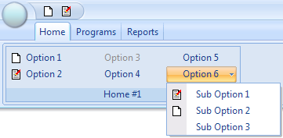
Figure 6: Tab menu with submenu popup

The Next Steps
Now that the basic framework exists there are a few things that need to be done to tidy up around the edges and to add some additional functionality, most notably expand the event handling and add skinning capability. It may be possible to make use of GDI+ for presenting the user interface but I think that the use of bitmaps and/or transparent pngs can achieve the same result with less pain.

Support for allowing the user to minimize the tab menu so that all that is seen are the menu tabs is something that needs to happen.

This parameter is a bit clunky and I think more thought needs to be put into handling this in an elegant way.

